Assignment

Mar23/ DBT/ 011
Database Technologies
Diploma in Advance Computing
March 2023

Sub-queries with joins.

USE student_phone, student_address, faculty_phone, faculty_address, batch_students, course_batches, student_qualifications, faculty_qualifications, course_modules, modules, faculty, student, course, student_cards, and student_order relation to solve the following queries.

- Display all student who have taken admission in more than 2 batches.
- Display the student detail who have joined the same batch of the student ‘saleel’.
- Display all courses where least number of students have taken the admission.
- Display student details who havenot taken the admission.
- Get all courses where no modules are defined in course_modules table.
- Display course_batchesdetails where student has taken the admission.
- Display all students whose marks of ‘BE’ is more than ‘ULKA’ marks in ‘BE’.
- Display all students whose marks are more than ‘saleel’ marks in 10th std.
- Display students whose DOB is as same as ‘kaushal’
- Display all student details who have three or more phone numbers.
- Display marks for the studentID 1 and 7 who have done ‘BE’. (Note: the marks must be displayed side by side).

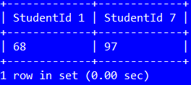

- Display marks for the studentID 1 and 7 who have done ‘BE’ also fine out the difference of marks between them.
(Note: the marks and difference between the marks must be displayed side by side)

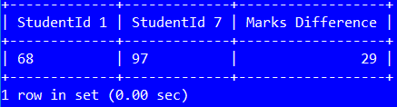

- Display all student who are not joined any of the batch.
- Display all course_batches details who are starting on the same day as ‘Batch1’.
- Display all students whose 10th marks is more than student ‘Neel’s 10th marks.
- Get all student with their qualification details who have highest marks in ‘BE’.
- Get all student with their qualification details who have second highest marks in ‘BE’.
- Display the student and student_qualification details who have scored the maximum marks in ‘BE’
- Display the student details who have scored the maximum marks in ‘BE’
- Display the student details who have scored the minimum marks in ‘10’ std.
- Display all student and student_qualification details of those students who have scored marks more than ‘RAJAN’ in ‘BE’.
- Display all student who have done ‘BE’ in the same year as of studentID 16.
- Display all odd records.
- Calculate the sum of marks student wise of their qualifications (i.e. 10th, 12th and BE marks)
- Display students’ details who are not having 'Aadhaar' card.

